The Gift of God
Luke 2:1-14
Introduction:
As the year comes to a close, there are many joyful events like graduations (this year, four people from our church graduated), getting jobs, the birth of grandchildren, and friends getting married. However, for those who are battling illness or have sick family members, these joyful events might feel distant, and it can be a tough time. During the Christmas season, many people are busy buying gifts. For some, it's a time of joy spent with family and friends, but for others, loneliness can lead to deep sadness and even suicidal thoughts.
Yet, beyond the good news and bad news we encounter in the world, there is a greater, truly joyous and wonderful news that transcends everything. It is the gift that God, who created us and knows all our circumstances, gives us. This is a gift that surpasses everything, a gift that brings eternal joy. What is this greatest gift we can receive?
First: The Roman emperor promised peace, but it was a false gift. The Roman Emperor issued a census decree for the whole Roman Empire. The Bible records: “In those days Caesar Augustus issued a decree that a census should be taken of the entire Roman world” (Luke 2:1).
The reason he issued the census was to collect taxes. After defeating Antony and Cleopatra's forces at the Battle of Actium, Caesar Augustus took control of the Roman Empire. Later, the Roman Senate gave him the title of "exalted and divine emperor," elevating him to a deified status. He promoted the Pax Romana, or Roman peace, promising peace to all the people in the empire.
However, despite this promise, people were still suffering from the effects of war. They lived in poverty and oppression, with many slaves, widows, and orphans. Caesar imposed heavy taxes on the colonies to maintain the Roman Empire.
Second: The true Savior, Jesus, the one who will truly give us the greatest gift has been born (verses 4-7).
When Emperor Caesar Augustus gave the decree, everyone had to go to their hometown, the land of their ancestors, to be registered (verse 3). Joseph and Mary, whose ancestors came from King David, had to go to Bethlehem, the land of their ancestors, nearly a thousand years earlier. The phrase “everyone went” means no one was exempt. This shows how harsh the decree was, as even full pregnant women like Mary had to go. During this time, there was probably great turmoil and mass movement of people throughout the Roman Empire.
For the poor, who were struggling just to survive, leaving their homes to travel for one or two months and pay travel expenses to be registered in their ancestor's land was incredibly difficult. Joseph had to travel 80 miles (128 kilometers) with his soon-to-give-birth wife, Mary. They likely traveled by donkey.
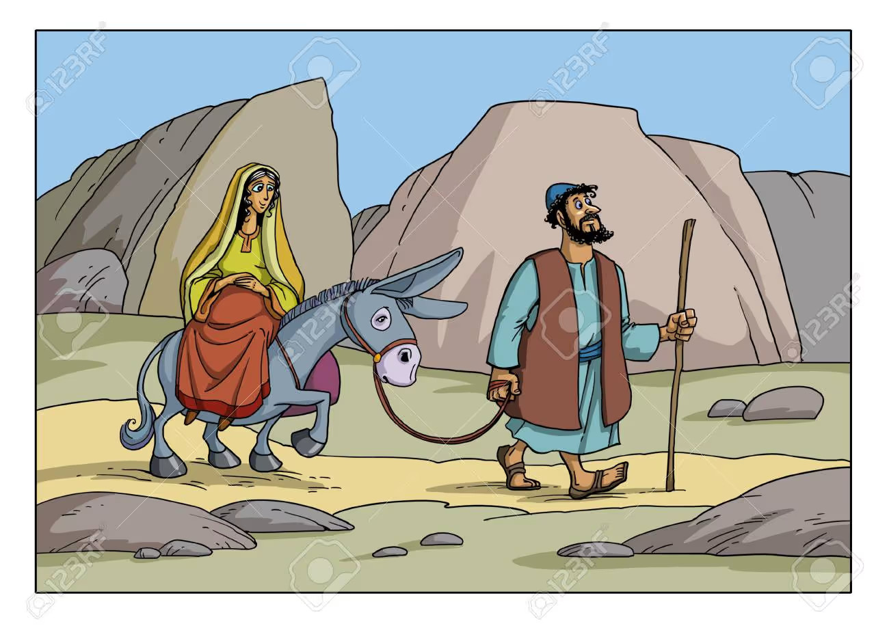

Joseph had to go to Bethlehem because of the emperor's order, even though he didn’t want to go. But God used this emperor’s order to fulfill the prophecy in Micah 5:2, which said that the Messiah would be born in Bethlehem. On the surface, it seemed like the Roman Emperor, Caesar Augustus, was in control of the world. But God was at work behind the scenes, using the emperor’s command to bring about His plan of salvation. The emperor was just a small part of God’s bigger history. Ultimately, God is the true ruler of history.
In the same way, God is guiding our lives today. It may seem like the world is led by powerful people and rulers. Even as believers, we may face business failures, sudden health problems, or feel like getting a PR visa has become much harder. It can feel like unknown forces are controlling our future.
But behind all of this, God is still at work. He is fulfilling His good plan for us. God is our ultimate Lord. Even when things are tough, no one can stop God's perfect and good will from being done. Through our struggles, God is shaping us into people of strong faith, valuable in His eyes.
At that time, the Roman emperor seemed very powerful, and it looked like he was making life hard for the people. But in truth, the hard times they were going through were the very moments leading up to the fulfillment of the prophecies about the coming of the Messiah. Over 40 prophets in the Old Testament had foretold the coming of Christ. God used the emperor’s census order to make Jesus be born in Bethlehem, just as it was prophesied.
Similarly, God knows the difficulties and pains we are facing. In the midst of these struggles, there is a deeper purpose that we may not always see. God is using these challenges to shape us into people who reflect Him, and He will use us for His plan of salvation. Let us trust in God, believing that He is in control of everything.
While they were in Bethlehem, the time came for Mary to give birth. She gave birth to her first son, wrapped Him in cloths, and placed Him in a manger.




Why was Jesus born in a manger? The Bible tells us in verse 7 that there was no room in the inn. This shows the harshness of people's hearts at that time. Even if there were no rooms available, it is common sense to offer a place for a mother about to give birth. Yet, no one offered a room to Mary and Joseph. If Joseph had had more money, perhaps he could have rented a room, but it seems he didn’t have much money. In this situation, as the time for the birth came, Mary had to give birth in a stable. She wrapped the baby in cloths and laid Him in a manger.
This baby Jesus wasn’t welcomed and was born in a manger. At that time, no one noticed His birth. The people of Bethlehem were likely busy eating, partying, and enjoying themselves.
Thirdly, Then, the angels appeared to the shepherds to announce the greatest gift of good news of great joy (verses 8-14). In verses 8-10, we see that the angels brought this Christmas message to the shepherds. What were the shepherds doing at that time? They were out in the fields at night, keeping watch over their sheep. The angel of the Lord appeared to them, and the glory of the Lord shone around them. The shepherds were terrified. But the angel said to them, “Do not be afraid. I bring you good news of great joy that will be for all the people. Today in the town of David a Savior has been born to you; He is the Messiah, the Lord.”
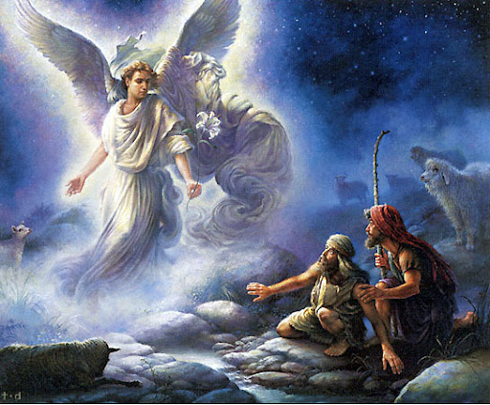

Why did God choose to send the Christmas message to these shepherds first? At that time, shepherds were considered to be of low social status. They were often known as people who could not be trusted, and their testimonies were not even accepted in court. They were outcasts, ignored and looked down upon by society. But God chose to send an angel to them to deliver the message of Jesus’ birth first.
The baby Jesus appeared so humble and weak in the eyes of people. But in God’s eyes, this birth was the most glorious moment. It was the moment when God’s promises, made through countless prophets, were being fulfilled. Yet, the response from the people was cold and indifferent. If the news of the Messiah being born in a manger had reached the palace or the homes of the wealthy and powerful, they would have dismissed it as nonsense. If Herod had heard this news, he might have sent his army to kill the child. The religious leaders were indifferent, and they were not even expecting the Messiah. The people of Jerusalem, upon hearing that the King of the Jews had been born, were troubled. They were not waiting for a Savior.
However, the shepherds, upon hearing the message from the angel, immediately went to see the newborn Jesus. The shepherds were the first to accept the good news and go to see the Savior.
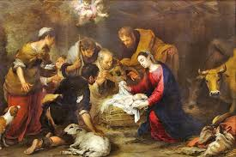

God did not send the message of the Messiah to those who would ignore it. This is still true today. People who feel they lack nothing, who are overly focused on Christmas gifts, parties, and the media, often do not hear the Christmas message. But for those who recognize the deep need for a Savior in their lives, the message of Christmas is heard. We pray that our hearts be humbled so that we can meet the Lord.
The angel said that the birth of Jesus was good news of great joy for all people. In the world, good news can be good for some but bad for others. But the coming of Jesus was truly good news for everyone. Why is the arrival of Jesus the best news?
The fundamental problem of humanity is that because of sin, everyone must die. No one can live forever. Many people think that if they are healthy, live long lives, are wealthy, and do well by worldly standards, they will be happy. But that is not the case. The issue of sin and death, which is humanity’s greatest problem, must be resolved. Let’s imagine living for 100 years without war, illness, or accidents. Even then, a one-year-old child would still have a limited time to live—99 years, to be exact. A 25-year-old would have only 75 years left. I remember a girl from my university class who died at 37. A friend from the military, who was very healthy, passed away at 40 from liver cancer. None of us knows how much time we have left. If a doctor told us that we only had a year, six months, or three months to live, we would be deeply troubled. There is no one brave enough to face death without fear.
Why do humans have to die? Sin causes death for everyone. Jesus came to earth to save us from this death.
The angel said, “Today in the town of David, a Savior has been born to you; he is the Messiah, the Lord.” The Savior here refers to the One who saves us. Jesus came to earth as our Savior. He came to save us from sin and death. He came to save us from the consequences of sin, which lead to death. He came to free us from all kinds of bondage and addiction. He came to rescue us from all our emptiness and despair.
Look at verses 13-14: "Suddenly a great company of the heavenly host appeared with the angel, praising God and saying, 'Glory to God in the highest, and on earth peace to men on whom his favor rests.'"
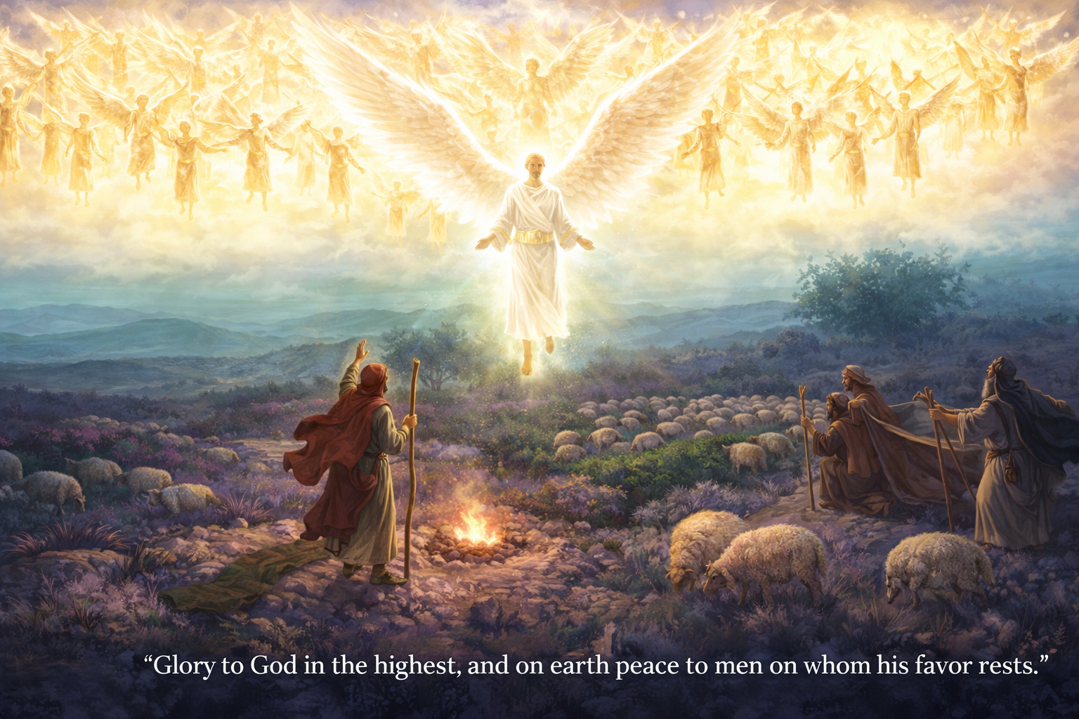

Because of the sin of the first man, Adam, and because of our own sins, every person is sentenced to death. We all must die because of sin. When we see criminals or thieves, we think they deserve to be condemned. However, within us, sinful thoughts constantly arise. God sees all the sins, even in our thoughts. He considers hatred as murder. This is why we are sentenced to death because of Adam's sin and our own sins. But then someone came to pay the price for our sins. Humans cannot fully pay the price of their sins, so Jesus, who is God, came to earth and died for us. He bought us with His own blood. Therefore, when we believe in Jesus, our sins are forgiven, and we receive the blessing of becoming children of God. So coming of Jesus is the greatest gift for us.
When we open our hearts and accept Him, we experience this greatest joy.
In verse 14, the angels say, “Glory to God in the highest, and on earth peace to men on whom his favor rests.” The peace mentioned here is not just peace from war or a calm heart; it is the restoration of our broken relationship with God, the reconciliation with Him.
In verse 11, it says that Jesus is the Savior, the Christ, and the Lord. The title “Christ” means that He is our true King, the Shepherd who leads us according to God’s will. Jesus is the One who saves us, and He is the One who leads us as we live on this earth. He helps us live a victorious life. As our Lord, He takes full responsibility for our lives and leads us through every trial. This Jesus, who is our King, comes to fight in our place and lead us to victory. He doesn’t just save us and then leave us to live alone, but He lives with us all the time.
Jesus is the One who saves us from all the schemes of Satan and gives us ultimate victory.
When we accept Jesus as our Savior, He leads us to ultimate victory. By experiencing the Kingdom of God, we live with God’s peace and heavenly hope on this earth. This is the Christmas gift that God has prepared for us.
Christmas is not just a time for shopping and exchanging gifts. It is a day to rejoice and celebrate the coming of Jesus Christ. May your Christmas be filled with joy and thanksgiving.

