Jesus, the Gate for the Sheep
Text: John 10:1–10
Introduction
Everyone longs for true happiness. We think that we will be happy if we meet good people, depend on them, and live with their support. Today, many people live as followers of someone. They follow the words of influential people in the media and on social networks. For a short time, this may seem enjoyable and helpful. But later, they may feel that they have wasted their time.
Some people also think they will be happy if their situation and conditions change. They think they will be happy if they earn a lot of money. They expect to be satisfied if they succeed or rise to a high position. Some also think their own life will be happy if their family, spouse, or children do well. However, the way to true happiness and abundant life is not simply found in better circumstances.
Today’s passage shows us how we can receive salvation, true freedom, and abundant life. Let us now look carefully at God’s Word.
1. The True Shepherd and the False Shepherd
“The one who does not enter the sheep pen through the gate, but climbs in by another way, is a thief and a robber. The one who enters through the gate is the shepherd of the sheep.” (John 10:1–2)
In verses 1 and 2, Jesus compares the true shepherd with the false shepherd. The true shepherd enters the sheep pen through the gate. But the thief and the robber do not enter through the gate. They climb over the wall somewhere else.
In the land of Israel, grass near the village often became scarce during the dry season. Shepherds sometimes took their sheep far away to places where there was grass. At night, several shepherds might put their sheep into the same sheep pen. The sheep pen had one proper entrance, and a gatekeeper watched the gate. The gatekeeper knew the true shepherd and opened the gate for him. The true shepherd had nothing to hide, so he entered openly through the gate. But a thief or robber wanted to steal and harm the sheep, so he avoided the gate and climbed in somewhere else.

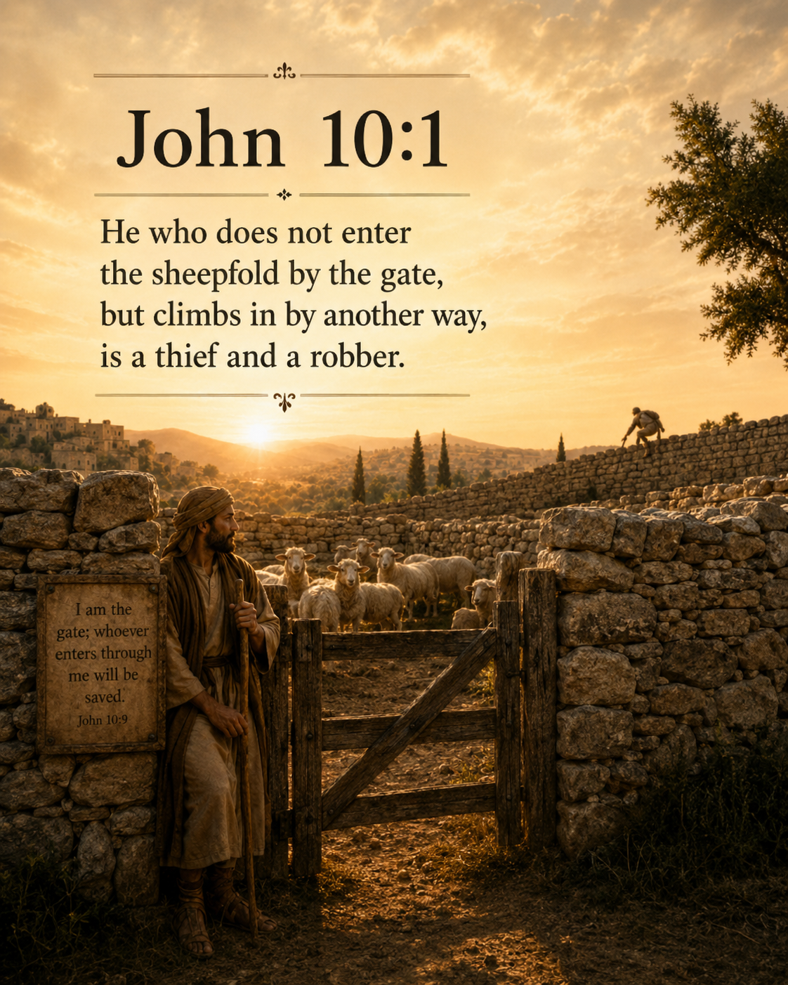
Jesus came to this world as the Messiah promised in the Old Testament. He came according to God’s will and God’s way. John the Baptist also testified that Jesus is the Son of God and the Messiah. Jesus did not come secretly to use the sheep. He came as the true Shepherd sent by God.
John 10 is closely connected to John 9. In John 9, a man who had been blind from birth received his sight through Jesus. It happened on the Sabbath. Instead of rejoicing that the man could now see, the Pharisees questioned him many times and pressured him to say that Jesus was a sinner. But the man boldly testified that Jesus had come from God. Then the Pharisees threw him out of the synagogue.
At that time, being put out of the synagogue did not simply mean that a person could no longer enter one place of worship. It meant being excluded from the religious, social, and economic community. This was a very serious matter. The Pharisees cared more about protecting their own interests and religious privileges than about the healing of a man who had been blind. They pressured him to deny Jesus. When he refused to give in, they expelled him.
But Jesus did not abandon the man. When Jesus heard that he had been thrown out, he went to find him and met him personally. Jesus showed him that he was the Messiah and helped him come to faith and eternal life. In the end, the man bowed down and worshipped Jesus. This is the difference between a false shepherd and a true shepherd. A false shepherd drives the sheep away in order to protect his own authority and interests. But Jesus, the true Shepherd, goes out to find the rejected sheep and gives them life.
2. Everyone Needs a True Shepherd
“The Lord is my shepherd; I lack nothing.” (Psalm 23:1)
Psalm 23 is a well-known and beloved passage that gives us great comfort. At the same time, it shows us what we are really like. If God is our Shepherd, it means that we are like sheep.
Sheep are weak. They have no weapons to defend themselves. They do not have a strong sense of direction, so they cannot easily recognise dangerous paths and they often get lost. When they fall or enter danger, they may not be able to escape by themselves. They are animals that truly need the protection and guidance of a shepherd. The Bible says that we human beings are like these sheep.
However, many people do not want to admit that they are sheep. They think they are strong and say, “I can manage my own life.” They believe that they know best where to go, how to live, and what will make them happy. They desperately need God’s guidance, but in daily life they often try to make decisions according to their own thoughts and desires.
When problems come, they look for Jesus. But they still want to make the important decisions by themselves. This is especially true in areas such as dating and marriage, money, work, and the future. In these matters, it is easy to put our own values and feelings before God’s will. With our mouths we say, “Jesus is my Lord. The Lord is my Shepherd.” But in our actual lives, we often live as if we are the master.
Many believers treat Jesus not as their Shepherd, but only as a helper or counsellor whom they call when they need something. A counsellor gives advice, but I make the final decision. A shepherd, however, guides the whole life of the sheep. If a sheep listens to the shepherd only in the morning when it goes to the pasture, but then wanders wherever it wants for the rest of the day, it may finally get lost and become food for a wild animal.
We do not need an adviser who helps with only one part of our lives. We need a true Shepherd to whom we can entrust our whole lives. Believing in Jesus as our Shepherd is the greatest blessing in life. It means living with Jesus and placing our daily choices, relationships, finances, and future under his guidance.
3. The Lord Knows the Names of His Sheep and Leads Them
“He calls his own sheep by name and leads them out. When he has brought out all his own, he goes ahead of them, and the sheep follow him because they know his voice.” (John 10:3–4)
The Lord knows each of our names. He knows our personality and weaknesses, our wounds and fears, our tears and failures. He knows how often we fall into sin. He also knows the pain and sadness that we do not want to tell anyone about. And he knows how to help us.
Jesus calls us by name when we remain comfortably in the small pleasures of the world and in sin. We often want to stay in our comfort zone. But Jesus calls us to come out of places where there is no true life, and he calls us to listen to his Word. Sheep know the voice of their shepherd very well. They have lived with him for a long time, heard his voice, and followed him. From experience, they know that when they follow the shepherd, they find food in green pastures and receive protection from danger.
[At this point, you may show a video of sheep hearing the shepherd’s voice and running to him.]
https://www.youtube.com/watch?v=Coq_grSFlNs

https://www.youtube.com/watch?v=STAda5RFrxM
12minutes 46 second -15:min
In this passage, “hearing the shepherd’s voice” does not mean only hearing a sound with our ears. It also means recognising the voice, trusting it, and actually following it. In the Bible, true hearing leads to obedience.
Then how can we hear the voice of Jesus? Above all, we hear him through the Bible. We can also hear his voice through prayer, sermons, meditation on God’s Word, and sharing our lives in the community of faith and in our house church group. When we stop our work for a moment and turn our attention to the Lord, the Holy Spirit helps us hear his voice. Like a shepherd who leads his sheep, the Lord calls us every day from the moment we wake up. He waits for us to come out. When we turn our eyes to the Lord, we begin to experience the God who gives us his Word and guides us.
False voices, however, make us proud, fill us with unnecessary fear, and help us make excuses for sin. The world says, “You must have more to be happy,” “You must be recognised by people to have value,” and “You are free only when you follow your own plans and desires.” If we continue listening to these voices, the voice of Jesus may sound weaker and weaker. When we are constantly exposed to media, we naturally become familiar with its voices and want to live by them. But the more we listen to the Lord’s voice, the sweeter it becomes to us, and the more we want to obey, trust, and follow him.
We do not follow Jesus because we know everything about the road ahead. Sometimes we do not understand why suffering comes or why our prayers are not answered at the time we want. But Job confessed, “After God has tested me, I will come out like pure gold” (Job 23:10). He also said, “My ears had heard of you, but now my eyes have seen you” (Job 42:5). We may go through pain and difficulty, but Jesus is our true Shepherd. In the end, he leads us on the best path. Faith does not mean understanding every road. Faith means trusting Jesus, the true Shepherd who knows the road of my life.
Therefore, we must stand humbly before God’s Word. We must keep God’s Word closer to us than the voices of the world. We should seek the Lord’s will in prayer, be sensitive to the leading of the Holy Spirit, and share our lives with one another in a living spiritual community. When we sincerely seek God’s will, the Lord guides us through his Word.
4. Jesus, the Gate for the Sheep
“Very truly I tell you, I am the gate for the sheep.” (John 10:7)
The Pharisees did not understand the picture that Jesus used. So Jesus explained it again in a clear way: “I am the gate for the sheep.” In John’s Gospel, Jesus uses several “I am” sayings to reveal who he is. Here he begins with the strong words, “Very truly,” showing how important this statement is. When Jesus says that he is the gate for the sheep, he means that he himself is the gate through which the sheep enter and go out.
The sheep enter the safe sheep pen through the gate. Then, under the shepherd’s guidance, they go out again and find grass. Jesus is the gate who leads us to salvation and life.
First, Jesus Is the Only Gate Who Leads Us to Salvation
“I am the gate; whoever enters through me will be saved.” (John 10:9)
Jesus says, “Whoever enters through me will be saved.” Jesus is the only gate who leads us to God. In John 14:6, Jesus also said, “I am the way and the truth and the life. No one comes to the Father except through me.”
In this passage, the words “will be saved” are in the passive voice. This means that we do not create salvation by ourselves. God saves us by the grace of Jesus. Salvation means being rescued from the danger of sin and death. It means being set free from God’s judgement and from the controlling power of sin. Salvation is not only being saved from the danger of hell and going to heaven. It also means becoming a child of God and living each day with God’s help.
Many believers think that because they already have a ticket to heaven, they can look for the happiness they want through other gates while living on this earth. They expect money, success, recognition, family, or religious activities to save and satisfy them. But these things cannot solve the problem of sin and death. They also cannot give us true happiness. True happiness and eternal life come only through Jesus. As we walk with Jesus, we can also live with true joy and satisfaction on this earth.
I am not saved because I hold on to Jesus perfectly. I am saved because Jesus holds on to me.
“I give them eternal life, and they will never perish. No one will take them out of my hand.” (John 10:28)
When we enter and go out through Jesus, we find pasture that gives life. “Pasture” means the grass that sheep eat. Jesus leads us to green pastures. He feeds us with God’s Word and, through the work of the Holy Spirit, brings us into deep fellowship with God. He helps us pray. He also helps us love and care for one another in the community of faith and grow spiritually together.
Second, Jesus Gives Us Life and Makes It Abundant
“The thief comes only to steal, kill, and destroy. I have come so that the sheep may have life and have it abundantly.” (John 10:10)
When we enter and go out through Jesus, the gate of salvation, and find pasture, we receive true life and enjoy its fullness. The life spoken of here is a life filled with joy. Salvation includes a change of status: we become children of God. But there is also an even fuller life. This comes as we follow Jesus and walk with him. Joseph believed in God. Even when he was a slave, he was able to live a rich and excellent life because God was with him. God promises us a wonderfully abundant life. This life comes when we follow Jesus.
Satan lies to us and says, “If you live according to the words of Jesus, you will be restricted, life will be boring, and you will lose your freedom.” So he says, “Live however you want. Follow your desires.”
However, living however we want is not true freedom. When we follow our own desires, we become slaves to sin, slaves to money, and slaves to different idols and to other people’s opinions. At first, we think that we are choosing money, success, and pleasure. But later, those things begin to control us.
In contrast, when we accept Jesus as our Shepherd and follow him, we enjoy true freedom. He leads us into a more faithful life.
When we follow Jesus, we enjoy fellowship with God and live a full life. Even when our circumstances do not always go as we want, we can still rejoice, give thanks, and hold on to hope.
“Abundant life” does not mean that we will always become rich or that everything in this world will always go well. It means believing that Jesus is my Shepherd and living in deep fellowship with him. It means walking with him under his protection and guidance. It means living with confidence in God’s love and depending on him. Abundant life is being at peace with God, enjoying his forgiveness, and living as a citizen of heaven even while we are on this earth.
This life cannot be taken away by our circumstances or by other people’s opinions. Even when we fail, our value does not disappear. Even in suffering, we do not lose hope. Even death cannot separate us from the love of God that is in Jesus Christ.
Conclusion
Dear brothers and sisters, everyone wants happiness and an abundant life. So people try to find that way through good people, better circumstances, money, success, and recognition. But today Jesus clearly says to us, “I am the gate for the sheep.”
Jesus is not a counsellor whom we visit only when we need help. He is the true Shepherd to whom we must entrust our whole lives and whom we must follow. We want to live as if we are strong and wise. But in reality, we are like sheep who easily get lost and hurt. Therefore, the wisest way to live is to admit that we are sheep, listen to the voice of the Good Shepherd, and follow him.
Now let us listen more carefully to the Shepherd’s voice than to the many voices of the world. Let us not try to walk ahead of Jesus. Let us follow behind him. Then we will enjoy true freedom and abundant life.
Application of the Word
Before today’s Word, we need to examine ourselves. Saying that Jesus is my Shepherd and actually following him can be two different things. Please think about the following questions and examine your heart.
• Whose voice am I listening to most these days? Am I spending more time listening to the media, the values of the world, and other people’s opinions than to God’s Word? Even if it is only for a short time each day, we should read the Bible, pray, and listen carefully to the Shepherd’s voice. Let us listen to the Lord’s voice every morning and every evening.
• In what area of my life am I refusing to accept Jesus as my Shepherd and still trying to be the master? We must honestly place before the Lord our money, marriage, relationships, work, future, and any heart that refuses to forgive.
• Am I trying to gain happiness and safety through another gate instead of Jesus? Money, the quick pleasures offered by media, physical pleasure, success, and human recognition can never be the gate of salvation or our true shepherd. We must welcome Jesus into that place. Let each of us make one decision this week and share it in our house church group.
• Even when the Lord leads us on a road that we do not understand, let us trust the character of the Good Shepherd and quietly follow him.

Verses9-10 I am the gate; whoever enters through me will be saved. He will come in and go out, and find pasture. The thief comes only to steal and kill and destroy; I have come that they may have life, and have it to the full.

